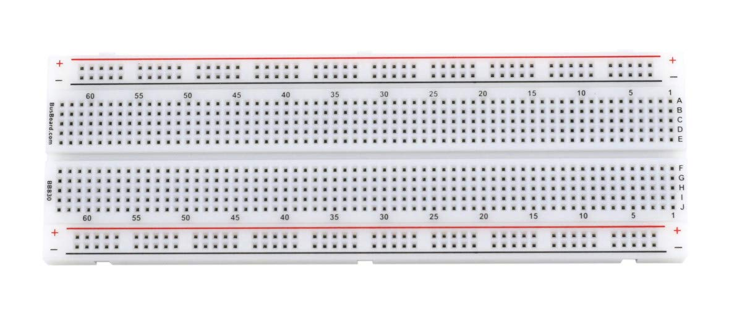

**6/12V DC Mini Small Solenoid Lock**

**Arduino LCD display**

**Tower PRO Micro Servo 9g**

**Arduino Keypad**

**HC-SR04 Ultrasound Sensor**

**Bread Board**

**REX Qualis Mega 2560**

1. **Bread Board**

2. **Arduino LCD display**

3. **REX Qualis Mega 2560**

4. **6/12V DC Mini Small Solenoid Lock**

5. **Tower PRO Micro Servo 9g**

6. **HC-SR04 Ultrasound Sensor**